**BAT 404 - Analytics Techniques and Tools**

Final Project Proposal Topic:   
EDA to Typhoon Mitigation and Response Framework (TMRF)

Group 2:

*Alvaro, Gabriel Edrian A.*

*Palis, John Arthur B.*

*Alangilan, Christine Joy M.*

*Guerra, Marian Z.*  
  
  
  
Batangas State University

**Abstract**

The Philippines' apparent vulnerability to natural disasters emerges from its geographic location within the Pacific Ring of Fire. The country is surrounded by large bodies of water and faces the Pacific Ocean, which produces 60% of the world's typhoons. Approximately twenty tropical cyclones pass through the Philippine area of responsibility each year, ten of which are typhoons and five of which are catastrophic (Brown, 2013). Due to a lack of preparedness and response, families in rural areas are more likely to be hit. According to the Weather Underground (n.d.), hurricanes are becoming a global threat as they solidify and more super tropical storms emerge. As a result, every municipality should have a high level of safety and security. However, government agencies and non-governmental organizations in the Philippines promote emergency preparedness, but they have yet to acquire the public's general attention like in Yolanda’s storm surge disaster where there is insufficient public awareness of storm surges, higher casualties have occurred (Commision on Audit, n.d.). The Commission on Audit also reported that the mayor of Tacloban City had stated that more lives may have been saved if storm surges were labeled as tsunami-like in nature. According to the National Research Council et al. (n.d.), preparedness is indeed the way of transforming a community's awareness of potential natural hazards into actions that strengthen its ability to respond to and recover from disasters and proposals for preparedness must address the immediate response and all the longer-term recovery and rehabilitation.

The objective of this analysis is to construct an Exploratory Data Analysis to Typhoons from the year 2019 that prompted the most casualty rates in the country and data on the municipal governments that had the least number of affected families’ individuals per typhoon in the Philippines. Moreover, a global dataset from 2000-2022 about hurricanes in the U.S. from the Centre for Research on the Epidemiology of Disasters' Emergency Events Database (EM-DAT) will be utilized in the same manner as mentioned in the Philippines Data set to know which Location in the United States had the most successful response and mitigation plan for typhoons. This information will be used to construct a Typhoon Mitigation and Response Plan that may help the Philippines deal with hurricanes. Integrating various programs from other countries will increase the likelihood of Filipinos' survival and recovery from typhoons.

**Problem Statement**   
 The primary issue addressed by this project is the lack of a mitigation and response framework among the cities and municipalities located throughout the Philippine archipelago. This was a significant component that might have a long-term impact on the lives of all Filipinos. Concerning this subject, the Senate Economic Planning Office (2017) conducted a study that evaluates the most often experienced problems and issues by various organizations in the Philippines. Among these concerns include a lack of coordination and collaboration amongst parties, the inadequate ability of line agencies and local government units to carry out DRRM tasks; reduced emphasis assigned to DRRM operations; inadequate enforcement of rules and policies; and scarcity of and difficulty in obtaining DRRM data/information. These are the concerns that this study seeks to address.

**Significance of the proposed project**

This data analysis research will provide fresh light on the country's reaction to and mitigation of the consequences of typhoons. This research will specifically benefit the following:  
 *Government* - This research will aid them in taking immediate action, prior to a disaster, to mitigate losses in the case of a typhoon disaster. The planning process and suggested ideas from established frameworks in the United States will assist them in determining how to plan, create, and develop the community while fostering risk-reduction collaborations.

*Community* - This research educates the community about the solutions and methods that might be implemented to ensure their safety during typhoon catastrophes and floods.

*Students* - Students would immediately benefit from this research since its findings may motivate them to investigate data analytics as a way to assist the community in which they live in developing efficient disaster mitigation and response plans, particularly for typhoons. They will also be informed of their precautions to safeguard themselves and their loved ones against storms and floods.

*Parents* - This research may persuade parents to pursue programs that include instruction to assist pupils in coping with the damaging impacts of typhoons.

*Future Researchers* – This paper discusses mitigation and response frameworks to minimize the devastation caused by typhoons. Thus, the findings of this study may be utilized to inform future conversations and analysis of effective frameworks employed by governments throughout the world that the Philippine government could adopt for its own system.

**Methods**   
 The primary issue tackled by this project is the inadequacy of a mitigation and response framework across the Philippine archipelago's cities and municipalities. This was a critical component that might have long-term consequences for the lives of all Filipinos. The Senate Economic Planning Office (2017) researches this subject, evaluating the most often encountered challenges and concerns by various organizations in the Philippines. The researchers will conduct an Exploratory analysis approach on the data sets selected for this study to address this. The primary objective of the exploratory analysis is to discover (Calzon, 2022). And according to IBM Cloud Education (2020), no concept of the link between the data and the variables existed before the analysis. Once the data has been analyzed, the exploratory analysis will assist the researchers in identifying linkages and developing ideas and answers to the deficiency of typhoon disaster mitigation and response frameworks in the Philippines.

**Reliability of the Organizations Where the Data sets Originated**

*Humanitarian Data Exchange Typhoon Data set 2019 from the Philippines:*

The Humanitarian Data Exchange Typhoon Dataset 2019 from the Philippines was utilized by the OCHA humanitarian organizations. To establish policies, manage inter-cluster issues, distribute operational guidelines, and organize field support, OCHA collaborates closely with global cluster lead agencies and NGOs. Furthermore, OCHA aids in the efficient operation of the humanitarian system and the management of the Humanitarian Coordinator. OCHA takes a critical part in functional coordination in emergency circumstances.

This incorporates surveying occurrences and necessities; concurring normal needs. Also, they are in charge of bringing humanitarian individuals together to enable a coordinated response to emergencies. They also send expertise to crisis-affected areas quickly, ensuring that the correct people are on the ground when new or worsening problems demand extra assistance. Most relevantly, OCHA advocates on behalf of those most impacted by humanitarian crises. They spread the word through media interviews, speeches, news conferences, web stories, and a publicity campaign.

The HDX or The Humanitarian Data Exchange is an open platform for exchanging data between humanitarian organizations and disasters. HDX, launched in July 2014, aims to make humanitarian data more accessible and usable for research (Sustainable Development Goals Helpdesk, n.d.). Users in over 200 nations and territories have accessed their increasing collection of datasets. HDX is administered by the United Nations Office for the Coordination of Humanitarian Affairs (OCHA) Centre for Humanitarian Data in The Hague. It is a new data platform that will enable humanitarians to access and exchange credible, up-to-date data. There is widespread agreement that data saves lives. Data enables the humanitarian community to develop short- and long-term strategies for providing vulnerable people with the assistance they need to create meaningful actions and decisions for the present society problems.

Collecting and maintaining data involves a variety of obstacles, particularly during the outset of a humanitarian crisis. Responders end up gathering a large amount of data on the ground in a variety of different formats during an emergency. This form of rapid, responsive data collection is beneficial for meeting the immediate needs of the impacted people, but less so when data sets are combined to examine patterns over time or provide detailed information of what is happening during a crisis. OCHA pioneered the creation of Humanitarian Data Exchange (HDX) following significant study. HDX is a new data-sharing platform that adheres to the highest data gathering standards, providing meaningful and reliable data access. HDX is a one-of-a-kind technology that will alter the role of data in humanitarian operations in the future, enabling organizations to give more focused help and adapt to changing requirements. As a result of this evidence, the organization's data sets are both reliable and suitable for data analysis purposes.

2000-2022 American EM-DAT from CRED

The second set of data comes from the CRED Center for Research on the Epidemiology of Disasters. In 1971, Professor Michel F. Lechat of the Université catholique de Louvain, an epidemiologist, launched a research program to examine health difficulties in crisis scenarios. Two years later, he founded CRED as a non-profit organization with international recognition. In 1980, the Centre was designated as a World Health Organization (WHO) Collaborating Centre (European Commission, n.d.). This organization fosters disaster research, education, and information transmission. Its objectives include increasing the efficacy of developing nations' disaster management capacities and supporting policy-oriented research using the Emergency Events Database (EM-DAT).

The EM-primary DAT's mission is to support humanitarian action on national and international levels. The database provides critical core data on the incidence and consequences of more than 22,000 catastrophic disasters worldwide between 1900 and the present (Centre for Research on the Epidemiology of Disasters, n.d.). CRED has been involved in the domains of international disaster and conflict health research for more than 40 years, with programs spanning relief, rehabilitation, and development. The Centre fosters humanitarian emergency research, training, and technical skills, notably in public health and epidemiology. This indicates that the data sets they've supplied are the result of their years of research and skill. As a result, the second data set that will be used in this study is suitable for data analysis.

**Objectives:**

The Philippines is a tropical country that lies within the equator, which means that it is prone to disasters like typhoons. A data set from the Humanitarian Data Exchange posted by Joseph Addawe (2019), an employee of the United Nations Office for the Coordination of Humanitarian Affairs office (OCHA) in the Philippines encoded all typhoons which landed and gravely damaged the country in 2019. Another dataset will be of use on this data analysis is from the CRED's Emergency Events Database (EM-DAT) from the year 2000-2022. This project aims to evaluate this data sets and obtain knowledge that will help the researchers obtain the following outputs:

*Humanitarian Data Exchange Data set about Philippines (2019)*

1. Determine the top 5 typhoons from 2019 that brought the greatest number of infrastructure casualties to the Provinces in the Philippines based from Totally Damaged Houses x variable.

2.Acquire the data about the Provinces who had the greatest number of affected individuals per typhoon (Affected_Pers).

3. Get the information that shows the top 5 municipalities who were most affected by typhoons from the year 2019.

4. Determine which typhoons (Top 5) are the strongest base from the Maximum wind speed x variable.

*The Centre for Research on the Epidemiology of Disasters' Data set about the American Typhoons (2000-2022)*

1. Determine the typhoon(s) from 2000-2022 that brought the greatest number of casualties to the different countries in America.

2. Acquire the data about the top 5 countries who had the greatest number of deaths, injured, and affected individuals from the typhoons on 2000-2022.

3. Get the information that shows the top 5 countries who were most affected in terms of economy (dollars) by typhoons from the year 2000-2022.

4. Determine which top 5 typhoons are the strongest based from the x variable ‘Dis Mag Scale’ or the magnitude of the disaster at its epicenter with the values in kph (kilometer per Hour).

The main objective of this analysis would be to obtain the data which will determine the municipality(s) from the Philippines and location(s) from America who had the most successful response and mitigation plan to typhoons. Their planning systems would be analyzed by the researchers to find what things the current plans of the Philippine Government are lacking in terms of typhoon disaster response plans compared to that of America.

**Data Sets Normalization**

Data normalization greatly helps in restructuring and use of data gathered from various sources. It also improves data readability for the team members, allowing for a more effective plan to create data visualizations to focus on the important areas of a dataset by effectively suspending the irrelevant entries from the view to avoid data anomalies. The data set that was needed to be normalize is the 2000-2022 data set from America as it contains rows that will not be of use for this project like the Geostorm, floods, and other types of disasters. These disaster types are subjected to be removed.

To normalize the data set, the project analysts used Microsoft Excel. They began by selecting the filter option under the home tab, followed by the sort and filter option in the drop-down menu. Next is the addition of the filters to the selected data range, a drop-down arrow was shown in the upper rows that was chosen to be filtered. The disaster type, blanks, storm and disaster subtype tropical cyclones were selected by the analysts. Following the sequence, only the selected data was displayed. There are two levels of normalization for this data set, and this normalization strategy is demonstrated below;

* Level 1: Based from the Disaster Sub-group x variable/column “Meteorological”

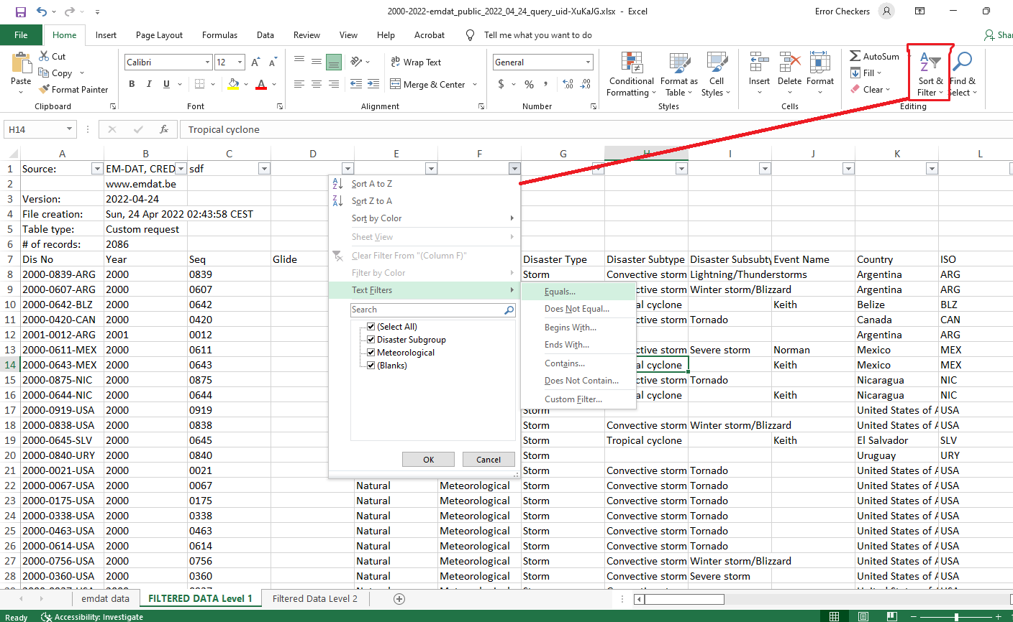

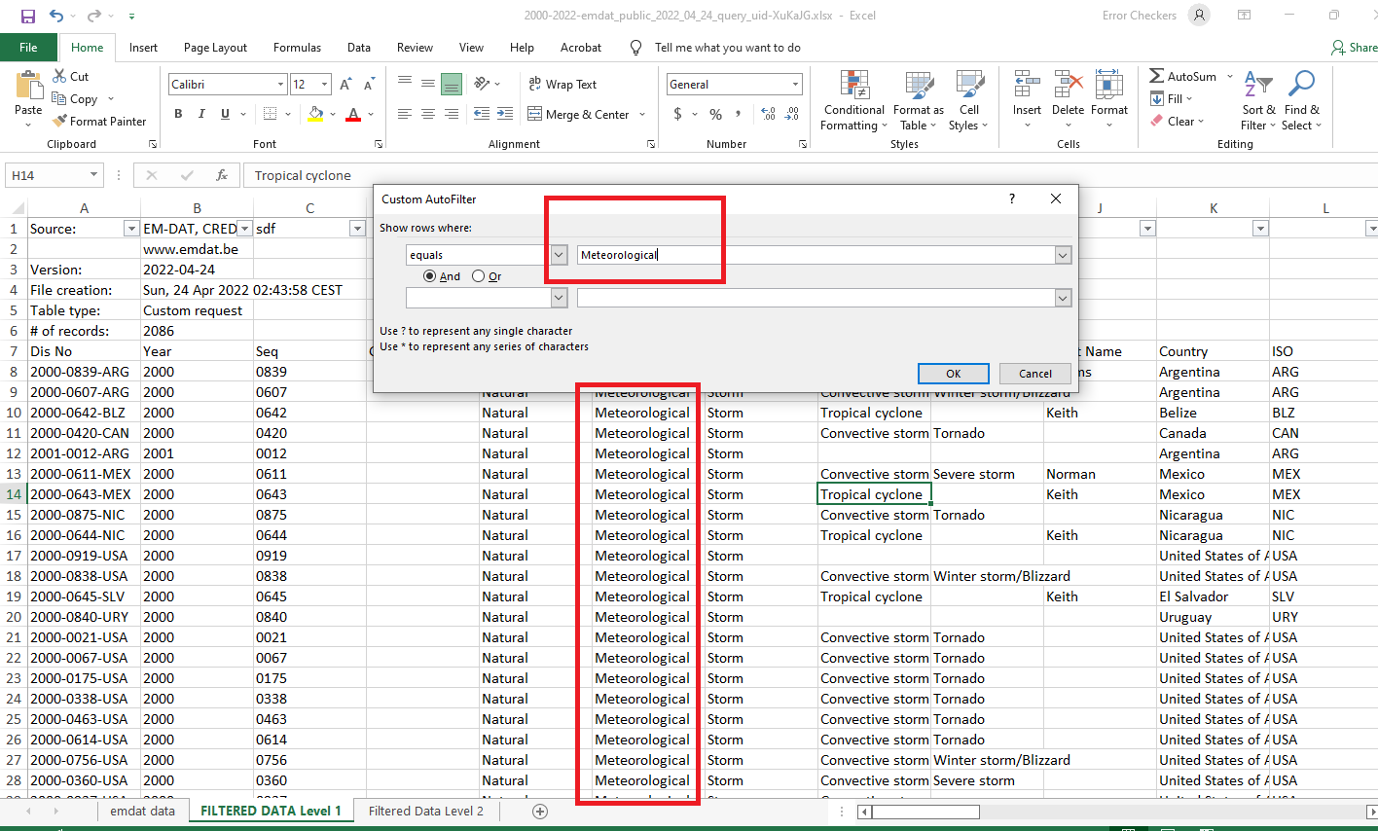

* Level 2: Based from the Disaster Sub-type x variable/column “Tropical Cyclone”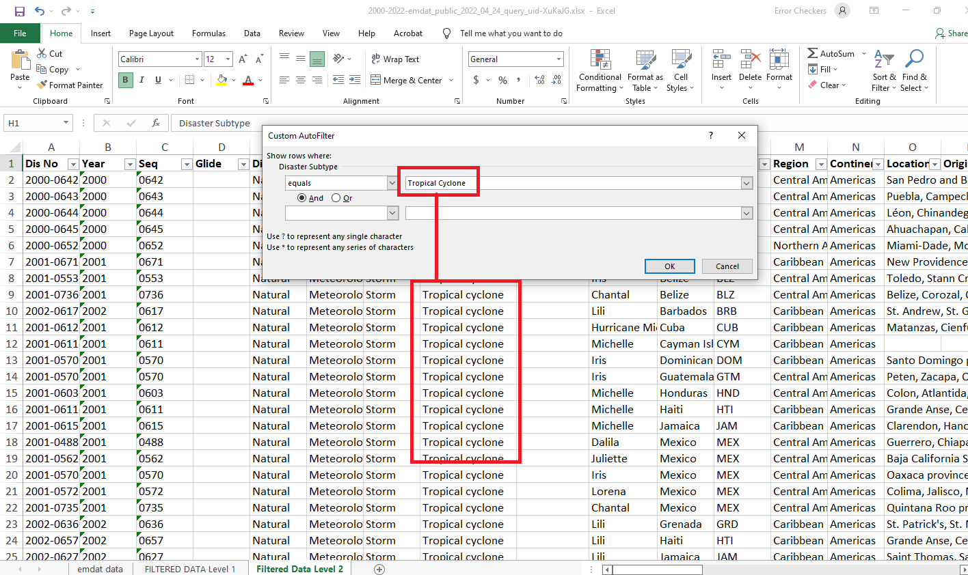

The subject data for this analysis is solely focus to tropical cyclone alone, so in order to achieve the objectives of this project; the data analysts perform data normalization in excel software. The analysis of these data sets would be further implemented on python using panda and NumPy modules.

**Data Analysis and Coding** The analysis for this project is consists of codes from python modules. And all of the analysis will be based on the objectives stated on this paper and will be arrange in same way of the objectives from both data sets were aligned. The codes and its outputs is demonstrated below;

**Expected output**  This research is planned to produce an exploratory data analysis of typhoons from the year 2019 that resulted in the highest casualty rates in the country and data on the local governments that experienced the fewest impacted families each typhoon. Additionally, worldwide hurricane datasets from the Centre for Research on the Epidemiology of Disasters' Emergency Events Database (EM-DAT) will be used in the same way as the Philippines Data set to determine which U.S. location had the best successful reaction and mitigation strategy for typhoons. This data will be utilized to develop a Typhoon Mitigation and Response Plan based on the one that the U.S. had, which can potentially assist the Philippines in dealing with hurricanes. By incorporating diverse strategies from other nations like the United States, the chance of Filipinos surviving and recovering from typhoons will likely increase.

**Sustainable Development Goals (SDGs) of the Project**

The SDGs which this project aims to attain are Sustainable Cities and Communities and Climate Action. These SDGs are further described as follows;

1. Goal 11: **Sustainable Cities and Communities** - This SDG strives to mitigate the negative consequences of natural catastrophes (globalgoals.org, n.d.).

2. Goal 13: **Climate Action** - This goal strives to take immediate action to address climate change and its consequences (United Nations, n.d.). Specifically, enhancing resilience and adaptation ability in all nations to climate-related dangers and natural disasters.

These SDGs are aligned with the TMRF project as it will provide a mitigation and response plan based on the tested and used framework by the U.S. government to their states. This framework will help the Philippine government in taking immediate action, prior to a disaster, to mitigate losses in the case of a typhoon disaster.

**Project Proponents**

Alvaro, Gabriel Edrian A. - **Project Manager**

Alangilan, Christine Joy M. – **Assistant Project Manager /** **Documentation Director**

Palis, John Arthur B. - **Presentation Manager**

Guerra, Marian Z. - **QA analyst (Proof reader)**

**Evaluation of the X variables inside the Data sets:***Humanitarian Data Exchange Typhoon Data set 2019 t from the Philippines*

|  |  |
| --- | --- |
| **X Variable** | **Definition** |
| Region | This is an administrative district of a town or nation that was affected by the storm. |
| Region code | This code denotes a specific region. |
| Province | A huge proportion of a country with its own governance. |
| Province code | This code denotes a specific province. |
| City_Mun | This is a city or town which has its own government. |
| City_Mun code | This code denotes a specific city/municipality. |
| Year | Year in which various typhoons occurred (2019). |
| Incident | The name of the tropical storm that passed through. |
| Maximum wind speed (Kph) | The strength of a typhoon in kilometer per hour. |
| Date Occurred | The date of an event takes place in relation to a particular time scale. |
| 2015 Population | The number of population in the year 2015. |
| Affected_FAM | The number of storm-affected families. |
| Affected_PERs | The number of storm-affected persons. |
| Inside_EC_Fam_Cum | Indicates the number of families inside evacuation centers in the present, which numbers are undetermined. |
| Inside_EC_Fam_Now | Indicates the number of families inside evacuation centers in the present, which numbers are determined. |
| Inside_EC_Per_Cum | Indicates the number of persons inside evacuation centers in the present, which numbers are undetermined. |
| Inside_EC_Per_Now | Indicates the number of persons inside evacuation centers in the present, which numbers are determined. |
| Outside_EC_Fam_Cum | Indicates the number of families outside evacuation center in the present, which numbers are undetermined. |
| Outside_EC_Fam_Now | Indicates the number of families outside evacuation center in the present, which numbers are determined |
| Outside_EC_Pers_Cum | Indicates the number of persons outside evacuation center in the present, which numbers are undetermined. |
| Outside_EC_Per_Now | Indicates the number of persons outside evacuation center in the present, which numbers are determined. |
| Totally damaged houses | The number of houses that have been completely destroyed as a result of the tropical storm |
| Partially damaged houses | The number of houses that have been partially destroyed as a result of the tropical storm |
| IDP_Cum | These are individuals or groups of individuals who are forced to leave their homes due to the disaster. |

*Events Database (EM-DAT) in America 2000-2022*

|  |  |
| --- | --- |
| **X Variable** | **Definition** |
| *Dis No* | This the disaster number in the year 2019. |
| Year | Year in which various typhoons occurred (2019). |
| Seq | This sequence provides catastrophic support to the idea that all social change usually follows. |
| Glide | This is the Global Identifier number assigned to all new disaster events. |
| Disaster Group | This is the disaster group name. |
| Disaster Subgroup | This is the disaster subgroup name. |
| Disaster Type | These are the types of disasters that come unexpectedly and cause significant damage. |
| Disaster Subtype | This is the disaster subtype name. |
| Disaster Subsubtype | This is the disaster sub subtype name. |
| Event Name | This is the disaster event name. |
| Country | The country where the disaster took place. |
| ISO | These are the internationally recognized codes used to denote each country. |
| Region | This is an administrative district of a town or nation that was affected by the storm. |
| *Continent* | This is one of the world's major landmasses. |
| *Location* | The location where the disaster occured. |
| *Origin* | This refers to the origin of the disaster that occured. |
| *Associated Dis* | The disaster that has occured as a result of the link catastrophe. |
| *Associated Dis2* | Other disaster that has occured as a result of the link catastrophe. |
| *OFDA Response* | This is the response of the Office of U.S. Foreign Disaster Assistance regarding to natural disasters. |
| *Appeal* | This is the disaster management appeal. |
| *Declaration* | This is the disaster management declaration. |
| *Aid Contribution* | This is assistance offered to support and help individuals or organizations. |
| Dis Mag Value | This is the disaster’s magnitude related values |
| Dis Mag Scale | It determines the magnitude of the disaster at its epicenter. |
| *Latitude* | The angular distance between the location of (north & south) and indeed the location of the disaster. |
| *Longitude* | The angular distance between the location of (east & west) and indeed the location of the disaster. |
| *Local Time* | This refers to the time depending on the meridian passing through a certain location. |
| *River Basin* | This refers to any area of land where precipitation accumulates and flows out. |
| *Start Year* | The starting year of the disaster. |
| *Start Month* | The starting month of the disaster. |
| *Start Day* | The starting day of the disaster |
| *End Year* | The ending year of the disaster |
| *End Day* | The ending day of the disaster |
| *Total Deaths* | The overall number of deaths as a result of the disaster |
| *No Injured* | The number of of people injured as a result of the disaster |
| *No Affected* | The number of people affected by the disaster |
| *No Homeless* | The number of the people who have been homeless as a result of the disaster |
| *Total Affected* | The total number of people who have been affected by the disaster. |
| Reconstruction Costs ('000 US$) | This is the cost of reproducing the building at present construction prices |
| *Reconstruction Costs, Adjusted ('000 US$)* | This is the adjusted cost of reproducing the building at present construction prices |
| *Insured Damages ('000 US$)* | This is the damage caused by an occurrence that must be covered by insurance |
| *Insured Damages, Adjusted ('000 US$)* | This is the adjusted damage caused by an occurrence that must be covered by insurance |
| *Total Damages ('000 US$)* | This is the total damage due to the disaster |
| *Total Damages, Adjusted ('000 US$)* | This is the adjusted total damage due to the disaster |
| *CPI* | This shows the average value change over time |
| *Adm Level* | This is the disaster's administrative level. |
| *Admin1 Code* | This code corresponds to admin 1. |
| *Admin2 Code* | This code corresponds to admin 2. |
| *Geo Locations* | It refers to physical location of a statistical unit |

**Reference Data Sets:**

Centre for Research on the Epidemiology of Disasters. (2022). 2000-2022 EM-DAT of America.   
 Retrieved March 2022, from Centre for Research on the Epidemiology of Disasters:   
 https://public.emdat.be/data

[Joseph Addawe](https://data.humdata.org/user/jaddawe), J. (2019). Philippines 2019 Events Data. Retrieved   
 March 2022, from Human Data Exchange Organization:   
 https://data.humdata.org/dataset/philippines-2019-natural-disaster-events-data

# **References**

Addawe , J. (2019). *Philippines 2019 Events Data*. (Office for the Coordination of Humanitarian Affairs office) Retrieved March 2022, from Human Data Exchange: https://data.humdata.org/dataset/philippines-2019-natural-disaster-events-data

Brown, S. (2013, November 11). *The Philippines Is the Most Storm-Exposed Country on Earth*. Retrieved March 2022, from world.time.com: https://world.time.com/2013/11/11/the-philippines-is-the-most-storm-exposed-country-on-earth/?fbclid=IwAR1xfQgQHZkgjZck_X9EBg_Jvj76wm7EL-I8OHJebNGkpLxIsEgHLxqPcrU

Calzon, B. (2022, March 9). *Your Modern Business Guide To Data Analysis Methods And Techniques*. Retrieved March 2022, from datapine.com: https://www.datapine.com/blog/data-analysis-methods-and-techniques/

Centre for Research on the Epidemiology of Disasters. (2022). *2019-2022 EM-DAT of America*. Retrieved March 2022, from Centre for Research on the Epidemiology of Disasters: https://public.emdat.be/data

Centre for Research on the Epidemiology of Disasters. (n.d.). *Welcome to the EM-DAT website*. Retrieved March 2022, from Centre for Research on the Epidemiology of Disasters: https://www.emdat.be/

Commision on Audit. (n.d.). *Disaster Management Practices in the Philippines : An Assessment*. Retrieved March 2022, from coa.gov.ph: https://www.coa.gov.ph/disaster_audit/doc/National.pdf

European Commission. (n.d.). *CRED - Centre for Research on the Epidemiology of Disasters*. Retrieved March 2022, from knowledge4policy.ec.europa.eu: https://knowledge4policy.ec.europa.eu/organisation/cred-centre-research-epidemiology-disasters_en

globalgoals.org. (n.d.). *Sustainable Cities and Communities*. Retrieved April 2022, from globalgoals.org: https://www.globalgoals.org/goals/11-sustainable-cities-and-communities/

IBM Cloud Education. (2020, August 25). *Exploratory Data Analysis*. Retrieved March 2022, from ibm.com: https://www.ibm.com/cloud/learn/exploratory-data-analysis

National Research Council, Division on Earth and Life Studies, Commission on Geosciences - Environment and Resources, U.S. National Committee for the Decade for Natural Disaster Reduction. (1991). *A Safer Future: Reducing the Impacts of Natural Disasters (1991).* Retrieved March 2022, from nap.nationalacademies.org: https://nap.nationalacademies.org/read/1840/chapter/7

Senate Economic Planning Office. (2017, May). *Examining the Philippines’ Disaster Risk Reduction and Management System*. Retrieved March 2022, from legacy.senate.gov.ph: https://legacy.senate.gov.ph/publications/SEPO/PB_Examining%20PH%20DRRM%20System_Revised_27June2017.pdf

Sustainable Development Goals Helpdesk. (n.d.). *The Humanitarian Data Exchange (HDX)*. Retrieved March 2022, from Sustainable Development Goals Helpdesk: https://sdghelpdesk.unescap.org/node/1086#:~:text=The%20Humanitarian%20Data%20Exchange%20(HDX)%20is%20an%20open%20platform%20for,over%20200%20countries%20and%20territories.

United Nations. (n.d.). *#Envision2030 Goal 13: Climate Action*. Retrieved April 2022, from un.org: https://www.un.org/development/desa/disabilities/envision2030-goal13.html

Weather Underground. (n.d.). *Prepare for a Hurricane or Typhoon*. Retrieved March 2022, from wunderground.com: https://www.wunderground.com/prepare/hurricane-typhoon?fbclid=IwAR33lsq6x66YI-9NFX94Ofy8jgC2TwH9gT__W9AItLA8P2pWyBJmnoYTM1w